Free Tools for Virginia Schools

Session Leader: Sue Way
Date: Wednesday, July 9, 2014
Objective: VA teachers have access to excellent resources, paid for by VA DOE grants and funding, which have been created in support of our Standards of Learning. These resources include: eMediaVA, Infinite Learning Lab, VA SOL-based apps in iTunes, Virginia on iTunes U, and more. Participants will learn about these valuable services and the instructional resources they provide.

Resources:

Infinite Learning Lab
https://learninglab.org/
Online lessons, activities and assessments in Life Skills, English, Mathematics and Science. Geared toward elementary and middle school students.

eMediaVA
http://www.emediava.org/
Similar to Discovery Education, however, all lessons, activities and resources are based on VA SOLs. Free for Virginia teachers and students. Features content from PBS Learning Media. Produced by a partnership with WHRO public television and several Virginia school districts.

Share the Skies
http://www.sharetheskies.org/home.cfm
The nation’s first statewide initiative that enables students to study astronomy in real time during the day without leaving the classroom. A related Astronomy course can be found on Virginia on iTunes U. An ebook, “Say Cheese, Moon!: An Introduction to Astroimaging, produced by the VA Department of Education is available for $5.99 in the iTunes store. Website includes student games and tutorials and lesson plans for teachers to use.

SketchUp Pro
3D modeling software – licensing paid for by the VA DOE. District technology leaders must obtain license codes from Jean Weller, jean.weller@doe.virginia.gov

iTunes U VA
In addition to the hundreds of resources from institutions such as Harvard, Stanford, Yale, etc, the VA DOE has developed an iTunes campus. The resources found here are based on VA SOLs and include videos, podcasts, lesson plans, and more.

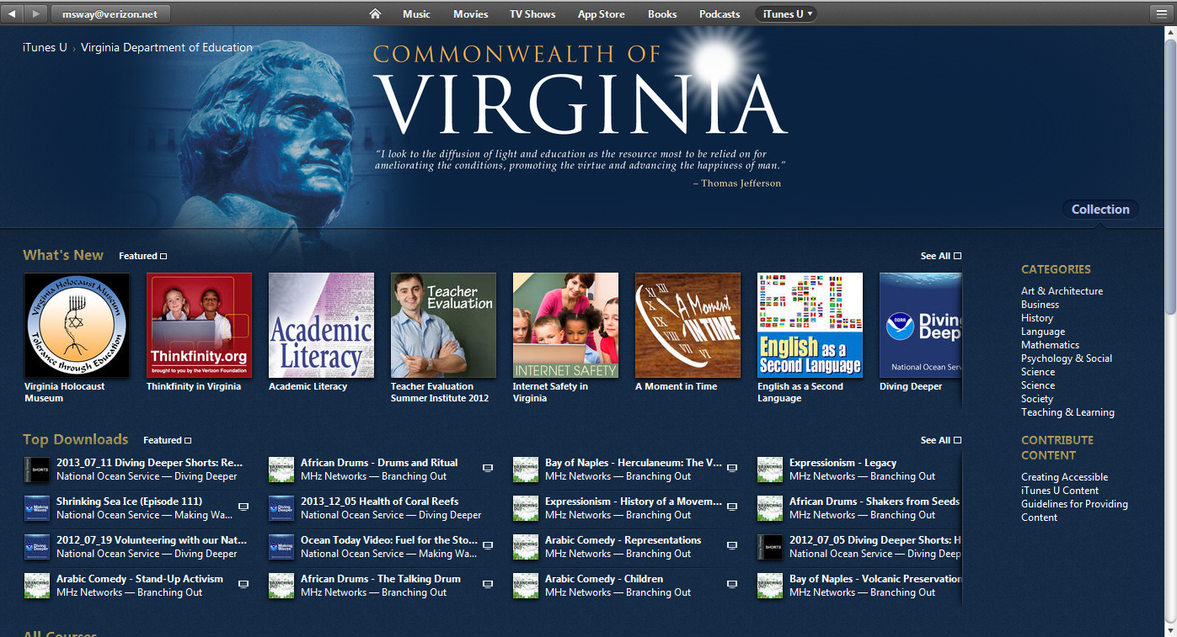

iPad and iPhone apps:
GAMeS Lab at RU – free apps created for Virginia schools through a grant from the VA Department of Education. Many have been made available for free through a partnership with WHRO public television.
Freddy Fractions
Computer Carl
Sticker Shop
Apples in Hour Hands
Fraction Factory
Equation Creator
Egberta’s Equations
Governomics
Zeppelin Adventure
Brain Flash
European Exploration: The Age of Discovery
Cell Defender
Disaster Chasers

WHRO (not in conjunction with GAMes Lab at RU)
Pass the Past
Master the Math
World History I GeoMaster
World History I Glossary
iCatchSquares

